

# TURNKEY AFRICA JIRA TRAINING DOCUMENTATION

Prepared by – Hannah Selekere

Presenter – Venessa Sila

**Table of Contents**

1 What is JIRA? 2

1.1 JIRA Scheme 2

1.2 Creating an issue in Jira 2

1.2.1 JIRA Issues and Issue types 2

1.2.2 What is JIRA Issue? 2

1.2.3 Issue Types 2

1.2.4 Issue priority 3

1.3 Creating an issue in Jira – Other fields 4

1.3.1 Sub-Task 8

1.3.2 WorkFlows 10

1.3.3 Use of Clone and Link in JIRA 10

1.4 Features of a good ticket 11

1.5 JIRA Agile 11

1.5.1 JIRA Scrum vs. JIRA Kanban 12

1.6 Reports in JIRA 13

1.7 Creation and Management of Dashboards 14

1.8 Portfolio 15

# What is JIRA?

JIRA is a tool developed by Australian Company Atlassian. It is used for;

* **bug tracking**
* **issue tracking**
* **Project management**

The basic use of this tool is to track issue and bugs related to a software(TurnQuest). It is also used for project management. The JIRA dashboard consists of many useful functions and features which make handling of issues easy.

## JIRA Scheme

Inside JIRA scheme, everything can be configured, and it consists of

* **Workflows**
* **Issue Types**
* **Custom Fields**
* **Screens**
* **Field Configuration**
* **Notification**
* **Permissions**

## Creating an issue in Jira

### JIRA Issues and Issue types

This section will guide you through JIRA Issue and it's types.

### What is JIRA Issue?

JIRA issue would track bug or issue that underlies the project. Once you have imported project then you can create issues.

### Issue Types

Issue Type displays all types of items that can be created and tracked via JIRA. JIRA Issues are classified under various forms like new feature, sub-task, bug, etc. as shown in the screen shot.

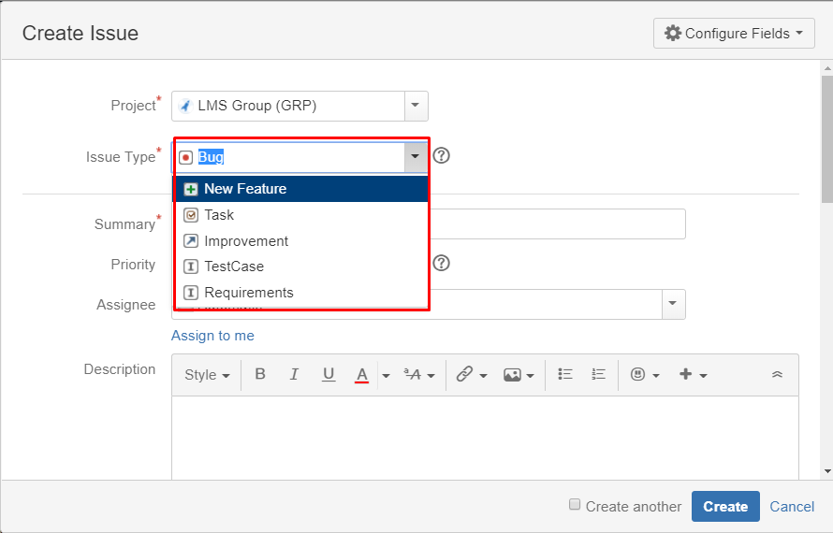

### Issue priority

Can be classified as;

* Blocker –Any issue blocking a user from proceeding with testing a project/deliverable.
* Critical-Any issue classified as critical in a client’s SLA
* Minor-Any issue that is not major as per the client’s SLA
* Trivial-Issues classified as would haves e.g cosmetic issues

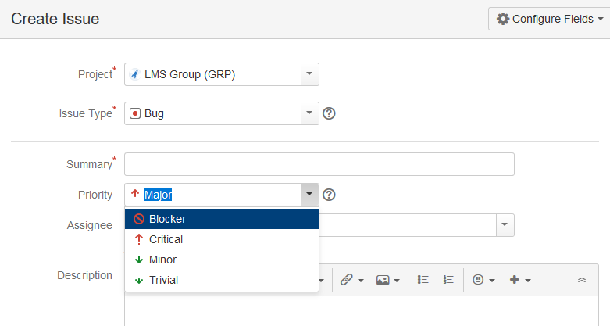

## Creating an issue in Jira – Other fields

When creating an issue in Jira, all the mandatory fields are marked with a red asterisk.

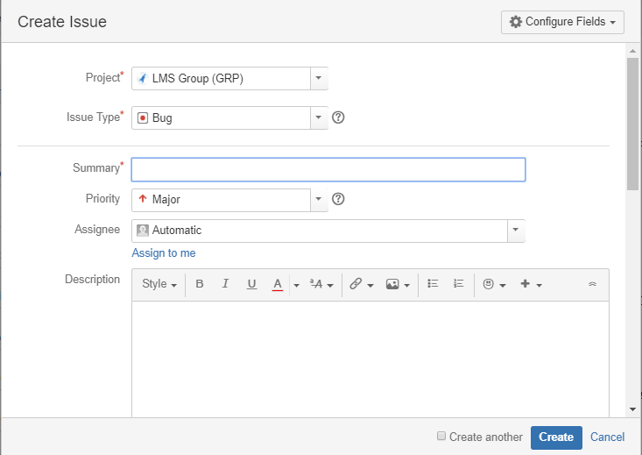

And

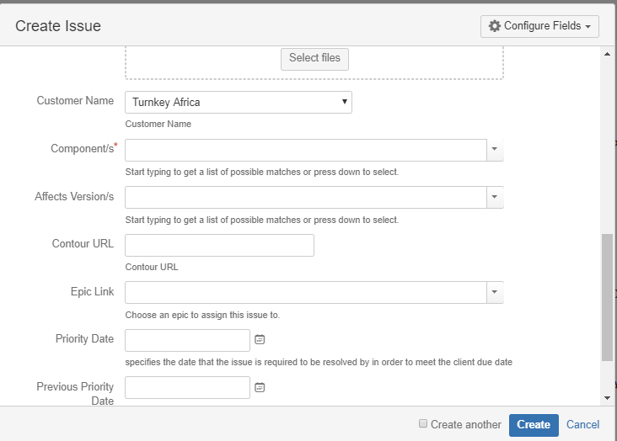

Once the issue is created a pop-up will appear on your screen saying your issue is created successfully.

Now if you want to edit an issue or you want to export the issue to XML or Word document, then you can hover your mouse on main panel and click on **Issues**. Under **Issues** options click on **search for issues** that will open a window from where you can locate your issues and perform multiple functions.

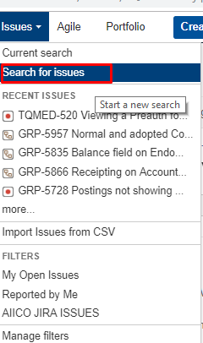

And

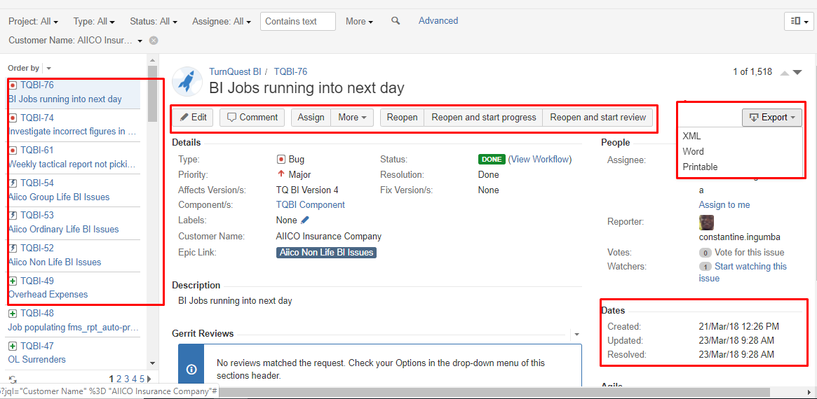

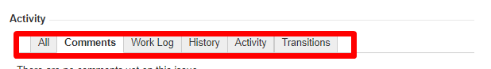

1. **Search for issues** option will bring you to a window where you can see the issues created by you like here we have issues TQBI-76 and TQBI-74
2. Here in the screen shot you can see the issue **"BI jobs running into next day"** and all the details related to it. From here, you can perform multiple tasks like you can **reopen and start progress , reopen and start review, assigning issues** and so on
3. Even you can export issue details to a XML or Word document.
4. Also, you can view activity going on the issue, reviews on the issue, work log, history of the issue and so on.
5. Under the time tracking option, you can even see the estimation time to resolve the issues

### Sub-Task

Subtask issues are useful for splitting up a parent issue into a number of smaller tasks that can be assigned and tracked separately. It addresses issues more comprehensively and segregates the task into smaller chunks of task to do.

#### How to create Sub-Task

Sub-Task can be created in two ways

* Create sub-task under parent issue
* Creating an issue into a sub-task

To create sub-task in JIRA, you have to select an issue in which you want to assign the sub-task. Under the issue window, click on **Assign more** option, and then click on **create sub-task** as shown in the screenshot below. You can also select **convert to sub-task** under same tab to convert the parent issue into a sub-task.

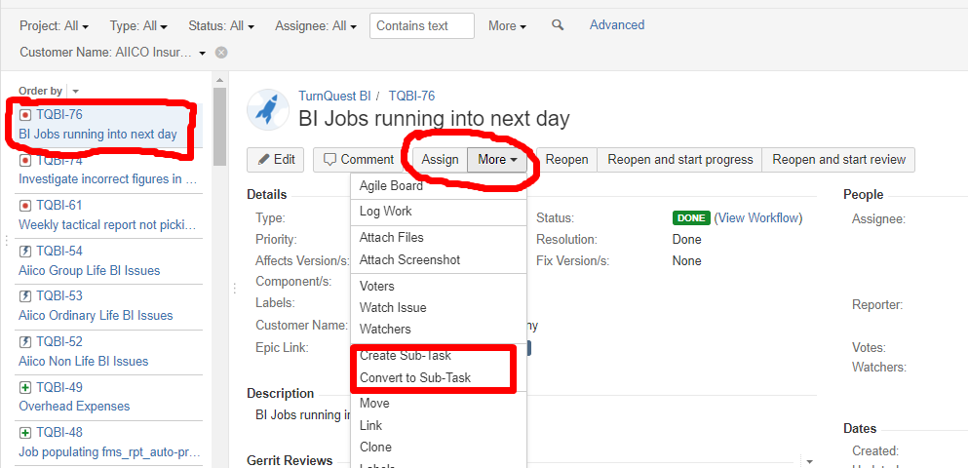

Once you click on **Create Sub-Task**, a window will pop up to add sub-task issue. Fill in the details about the sub-task and click on **Create** as shown in below screen-shot,and this will create sub-task for the parent issue.

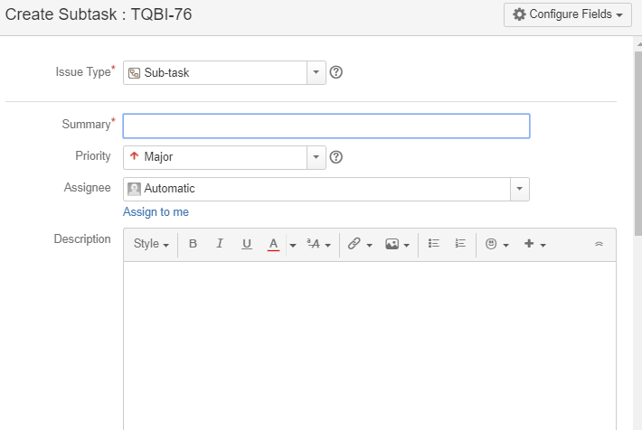

Some important points to remember while creating Sub-Task

* You can have as many sub-task as needed under an Issue
* You cannot have a sub-task for a sub-task
* Once a sub-task is created under a parent, parent cannot be converted into a sub-task
* A sub-task can however be converted into a parent issue
* You can work on your sub-task without having navigating away from the parent issue

### WorkFlows

A JIRA workflow is a set of statuses and transitions that an issue goes through during its lifecycle. JIRA workflow encompasses five main stages once the issue is created.

* Create Issue
* Resolved Issue
* Assign SME Issue
* In development
* Re-Opened Issue
* Close Issue

### Use of Clone and Link in JIRA

In JIRA, you can also clone the issue, one advantage of cloning an issue is that the different team can work separately on the issue and resolve the issue quickly.

Move –enables you to tag an issue to the correct project if it had been captured under wrong project

Linking –enables you to link an issue to another tool used for reporting issues eg Zendesk

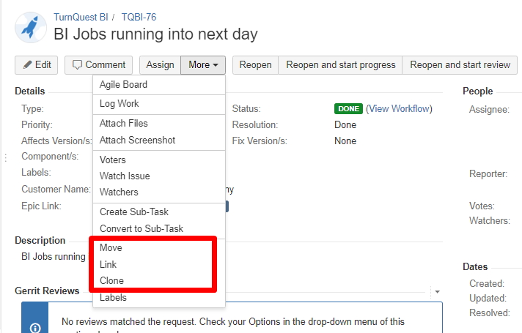 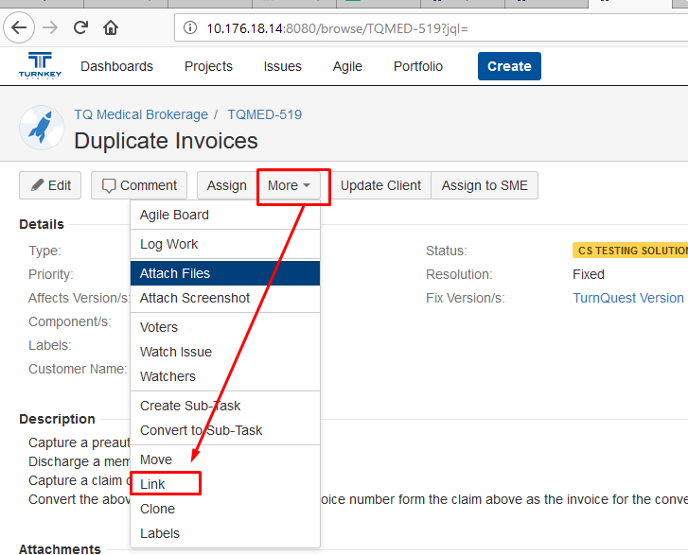 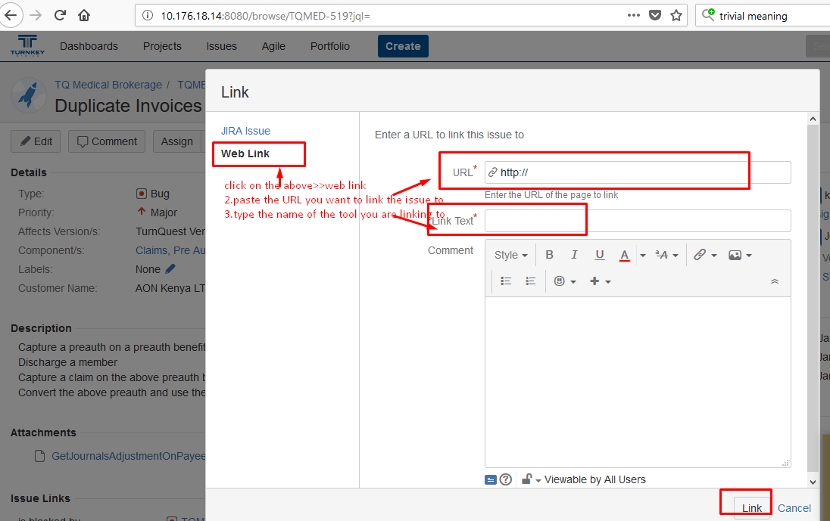

## Features of a good ticket

* Short, precise and adequately descriptive subject of the ticket
* Clearly outlines all the steps taken to arrive at the scenario
* The description of the ticket to clear and exhaustive. This is to be done in such a way that the developer can read the description, understand it and work on it without having to sit with the BA whatsoever.
* Gives the schema and link to the application where the scenario can be re-generated from
* Error messages and scenario documentation to also be attached
* The right priority date has to be entered to enhance planning and issue prioritization.

## JIRA Agile

Agile or Scrum method is generally used by development teams who follows a roadmap of planned features for upcoming versions of their product.

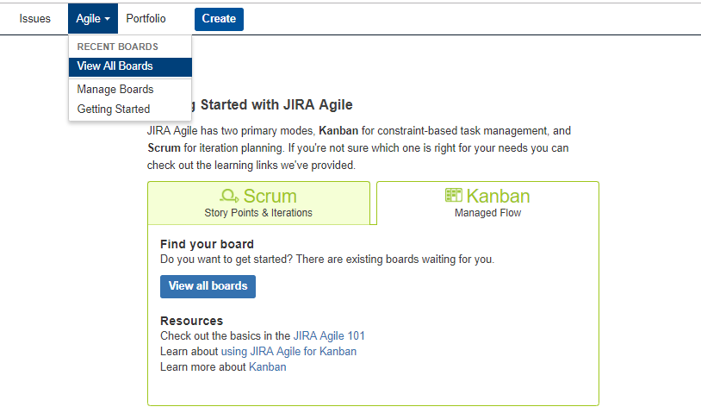

### JIRA Scrum vs. JIRA Kanban

|  |  |
| --- | --- |
| Scrum | Kanban |
| **Reports**  Burndown Chart: The chart shows all the changes and scope changed while the sprint is still on, other charts include Sprint Report, Velocity Chart, Epic Report, etc. | **Reports**  Control Chart: It allows you to measure the cycle time for issues, showing the mean time and actual time taken to complete issues |
| **Agile Board**  It allows the team to see the progress of sprints. This is the work mode, where you can see the board itself broken down into different statuses. | **Constraints**  Team can decide whether to increase or decrease the number of issues that should be displayed in each status. |
| **Backlog**  This is where team will plan sprints and estimate stories that will go into each sprint | **Workflow**  You can map columns to the statuses of your workflow. Simply by adding or removing columns the workflow can be changed when required. |

## Reports in JIRA

To track the progress in Agile, a **Burndown Chart** shows the actual and estimated amount of work to be done in the sprint. A typical burndown chart will look somewhat like this, where the red line indicates the actual task remaining while the blue line indicates ideal task remaining during the scrum cycle.

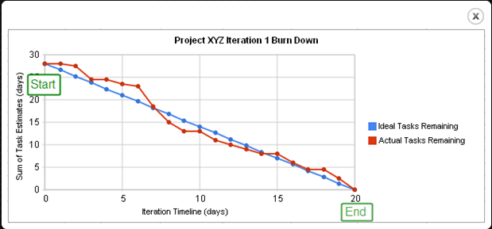

Apart from Burn down chart there are other options available in JIRA like **Sprint Report, Epic Report, Version Report, Velocity Chart, Control Chart, Cumulative flow diagram**. You can also use different chart option to represent the progress of your project.

**Filters**

You can also set filters other than default filters to filter the issues. The filters that you can use are **date, component, priority, resolution and so on.**

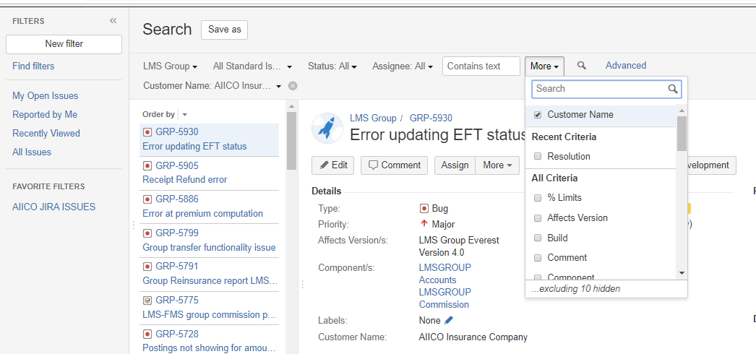

## Creation and Management of Dashboards

New dashboards can be created by entering the name, description of the dashboard, start date and the favorites then click add.

Dashboards which as marked as favorites will be appearing when the dashboards tab is selected. Click on Dashboards as highlighted below>>then manage dashboards

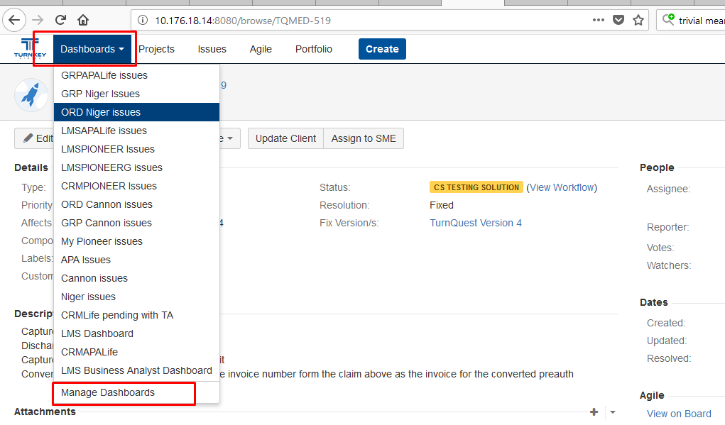Then click on create dashboard link on your far right as highlighted below 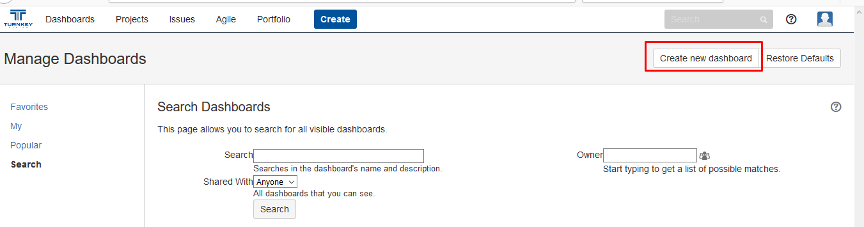Below screen opens

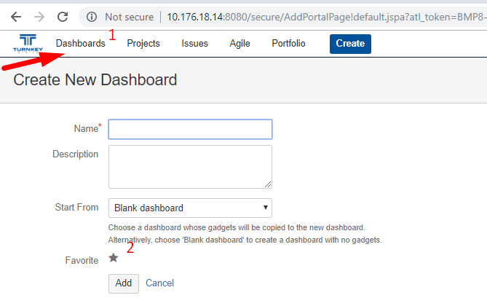fill in the above fields and click on add.

The below screen opens,click on my as highlighted for you to view the particular gadget created.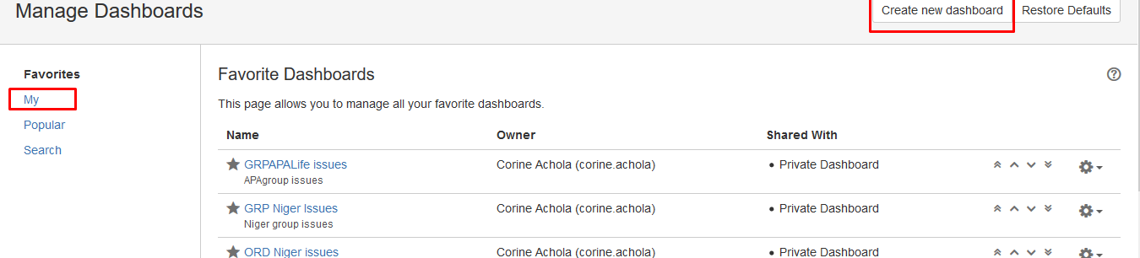

click on the dash board and add a favourable gadget that you would wish to work with.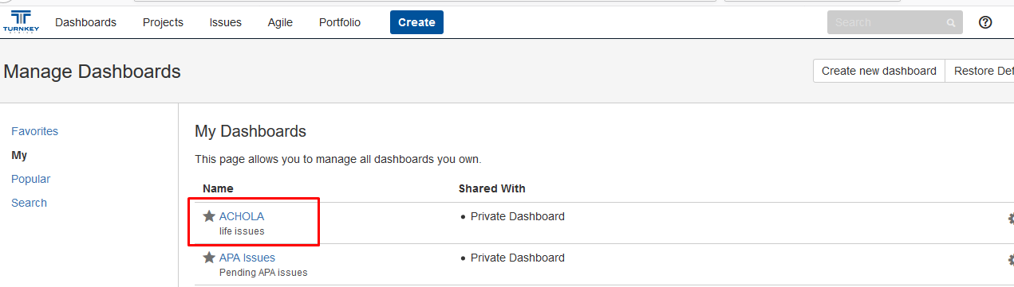 fill in the bellow fields an save .Filter name can be an existing filter created by someone else or a new filter created by you specifically for your projects.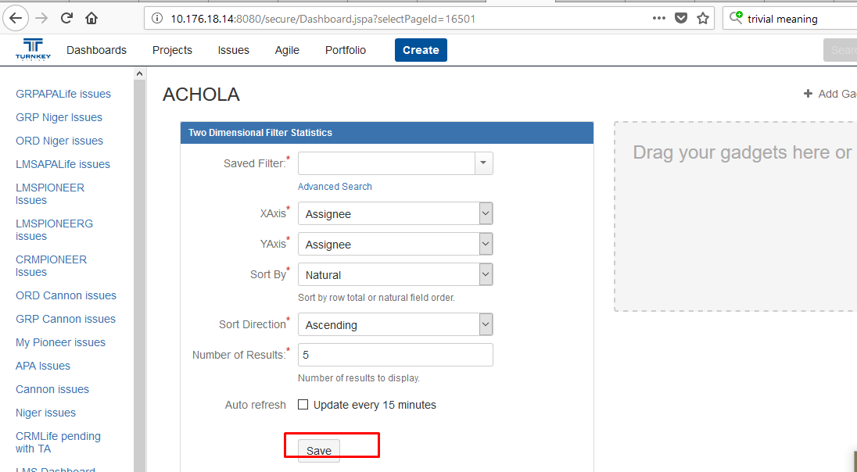

Under dashboard management, all those tagged as favorites will appear as illustrated below.

A dashboard can be edited, deleted or copied. It can also be private or shared with everyone.

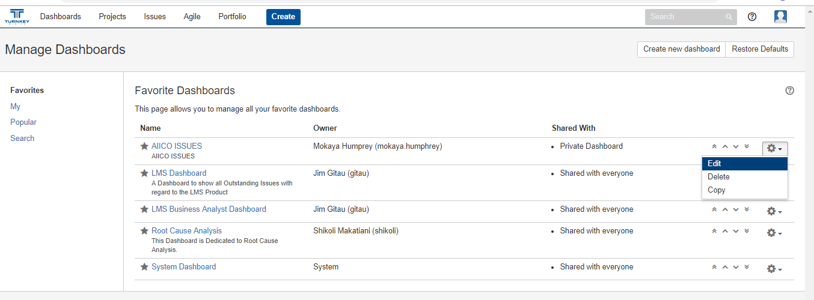

## Portfolio

Enables the user to add;

* Teams - e.g LMS Individual, GIS development team etc.
* People – individual Jira users
* Skills – Business analysis, development, project management etc.

